# **Lab 10**

# **GitHub Pages Documentation**

## **Introduction**

**GitHub Pages** is a free web hosting service provided by GitHub that allows you to host static websites directly from a GitHub repository. It’s perfect for portfolios, documentation, project pages, or any static content.

This guide will walk you through the process of setting up and publishing your website using GitHub Pages.

## **Prerequisites**

* A GitHub account
* A repository containing your static website (HTML, CSS, JS)
* Basic knowledge of Git and GitHub

## 

## **Steps to Deploy Your Website with GitHub Pages**

### **Step 1: Create or Use an Existing Repository**

If you don’t have a repository yet, create one:

1. Go to [github.com](https://github.com/)
2. Click on **New repository**
3. Name your repository (e.g., my-portfolio)
4. Initialize it with a README (optional)

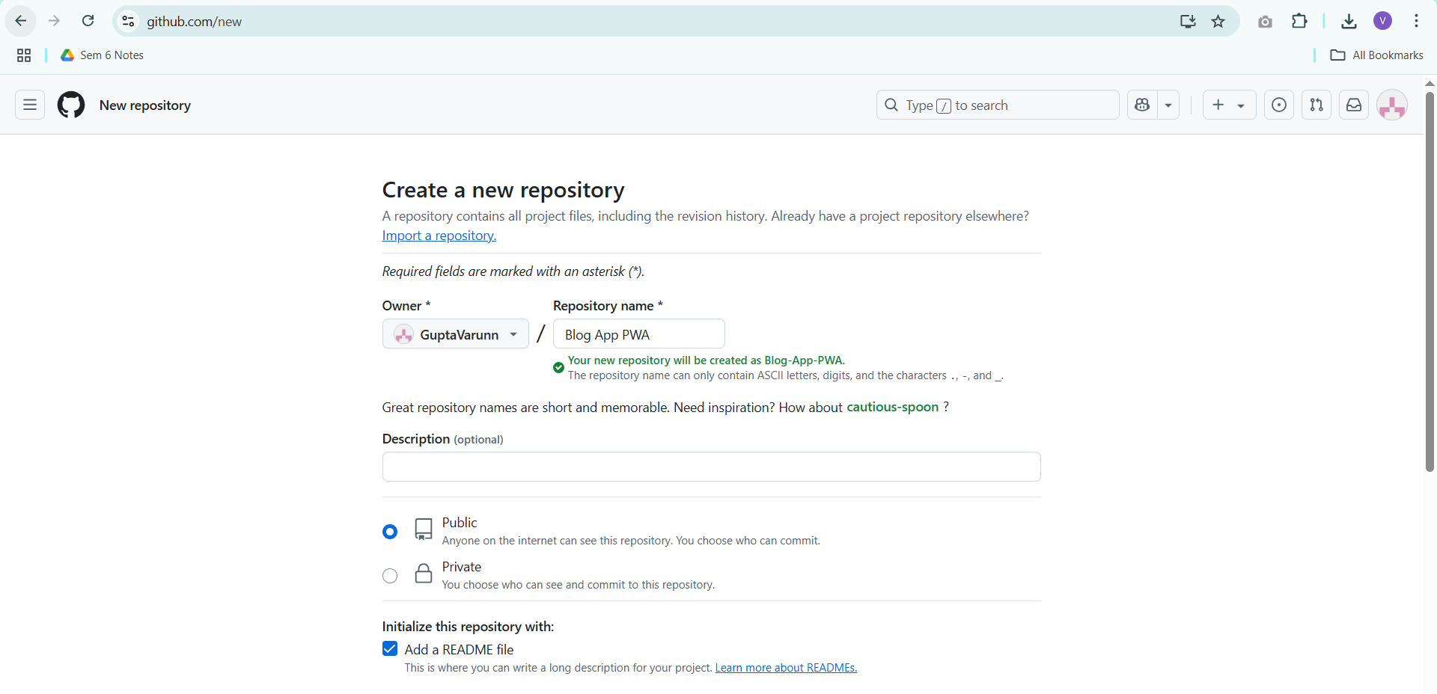

### **Step 2: Upload Your Website Files**

Make sure your repository contains the files you want to publish, such as index.html.

You can either:

* Drag and drop files on the web interface
* Use Git commands (git add, git commit, git push) from your local machine

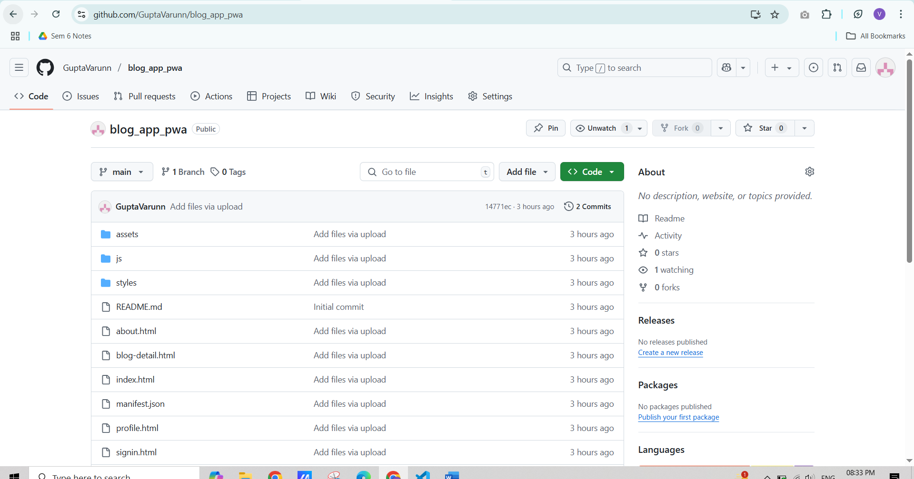

### **Step 3: Enable GitHub Pages**

1. Go to your repository
2. Click on the **Settings** tab
3. Scroll down to **Pages** in the left menu
4. Under **Source**, select the branch (usually main) and folder (e.g., /root or /docs)
5. Click **Save**

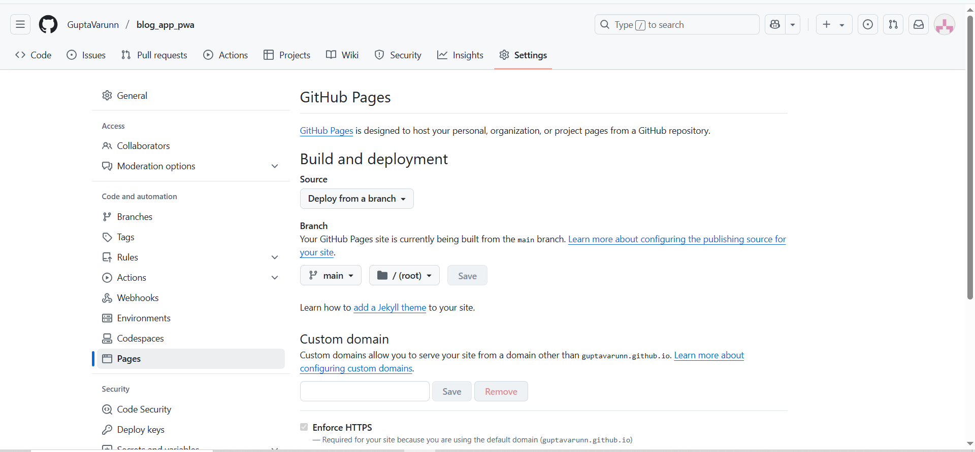

### **Step 4: Access Your Live Website**

After enabling GitHub Pages:

* Wait a few seconds
* You’ll see a link like:  
  https://guptavarunn.github.io/blog_app_pwa.github.io/

Click it to view your live site 🎉

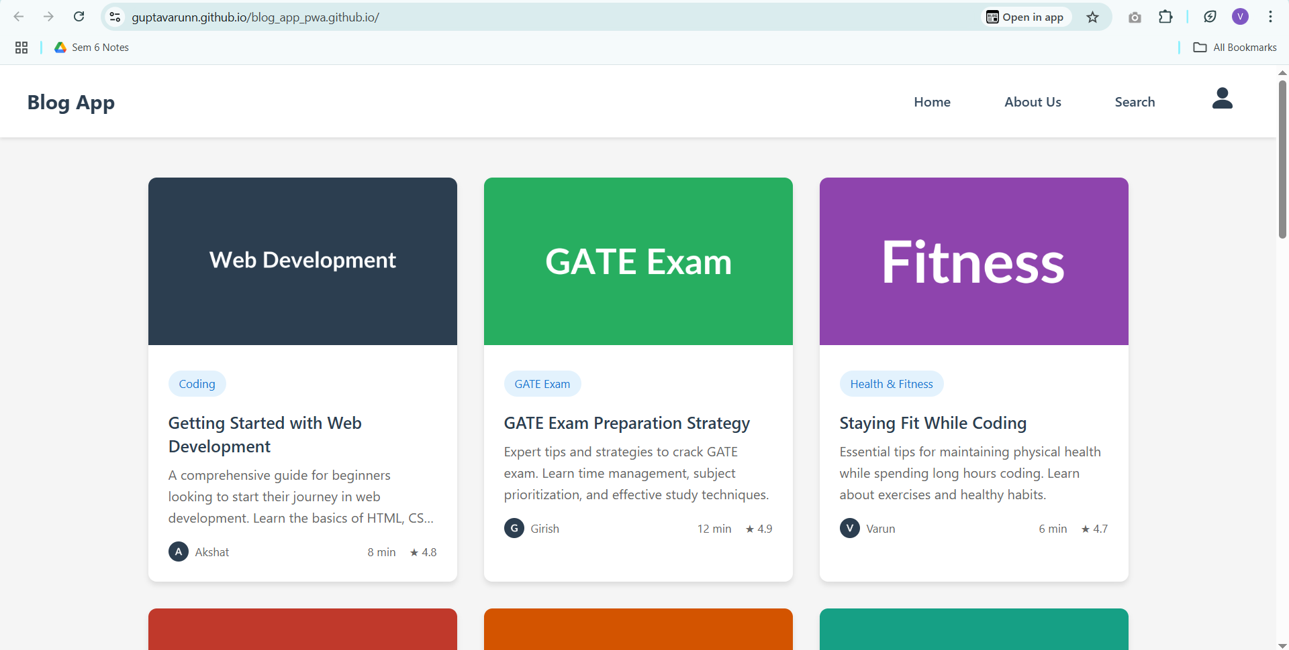

## **Tips**

* Your homepage must be named index.html
* You can use a custom domain by configuring the **Custom domain** section under GitHub Pages settings
* Use relative paths for assets to avoid 404 errors

## **Conclusion**

GitHub Pages provides an easy, fast, and free way to publish static websites directly from your GitHub repo. Whether you're showcasing a project or building a personal site, it's a powerful tool in your web development journey.